**Lesson 4 Demo 2**

**Demonstrate Ansible Modules**

**Objective:** To implement Ansible Module through command line

**Pre-requisites:** You need to have Ansible installed to proceed with this demo. If you don’t have it installed, refer to demo 1 of lesson 2.

**Tools required:** Ubuntu terminal, Ansible

**Steps to be performed:**

1. Executing Ansible modules on a local server

**Step 1: Executing Ansible modules with local server**

1.1 Run the below commands in the given sequence to execute different Ansible

modules.

**ansible -m setup webservers**

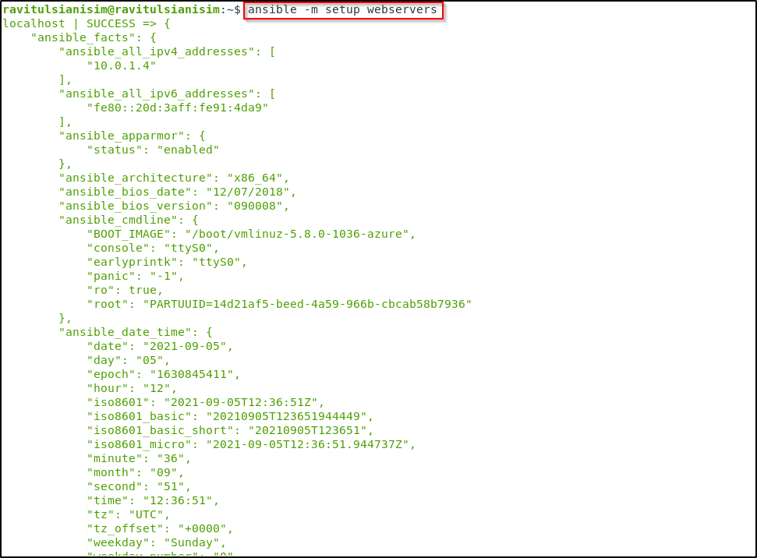

**ansible webservers -m shell -a 'hostname'**

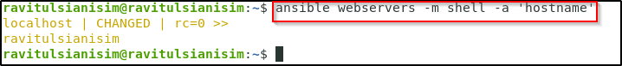

**ansible webservers -m apt -a 'name=git state=present' --become**

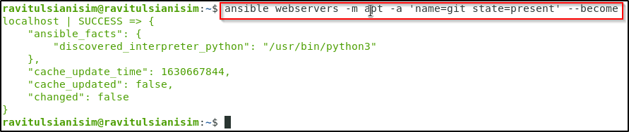

**ansible webservers -m file -a 'dest=/root/sample.txt state=touch mode=600 owner=root group=root' --become**

